

**Course name:** IT software for business

**Professor:** Anthony Lawson

**Student name:** Mila Kalusheva

**Bachelor’s program:** Bachelor of Arts in Leisure and Tourism Management

**Year:** 2021

Table of Contents

Question 1. Yansha has raced to catch up with the latest information systems and technologies, but remains a local Chinese business. What might Yansha’s next move be in order to increase its revenue? How might that move be successfully taken? 2

Question 2: You should be able to copy and paste the data above straight into excel. For each quarter, report the total value of sales, average order value, and standard deviation of orders, to two decimal places. Briefly explain which quarter you think was best, and why. 3

# Question 1. Yansha has raced to catch up with the latest information systems and technologies, but remains a local Chinese business. What might Yansha’s next move be in order to increase its revenue? How might that move be successfully taken?

In the rapid changing business world innovation is the key which ensures success and growth of the company. For a business organization it is crucial to switch from cost reduction to future investments if it wants to maintain high performance among the competition in the market, and with the help of innovation it can achieve it. The Chinese company Yansha, as one of the country´s biggest retailers, saw the threat of international rivalry and took action to prevent a fall in the revenues – by implementing technological systems they improved the communication with suppliers which resulted in reducing the time of delivery and saving costs. By reaching IBM China Research Lab to evaluate the company´s informational systems and propose a change in the manner of collecting data Yansha took the step to move forward in the competitive market and upgrade its marketing approach.

In order to increase the revenues, the management of Yansha should firstly identify the goals of the company and determine the approximate time necessary to attain them. This is related to the planning function of the manager and it is of great importance, because it is the base for framing the mission and the strategy of the business organization. Once doing, this the company acknowledges its place in the market and the manner in which could improve the efficiency of production and distribution. The following managerial actions are organizing, leading and controlling. The IT informational systems play a crucial role in the growth of the company because they deliver data, which is analyzed and evaluated, providing the base for the decision-making process regarding the strategic tactics of the company – “applications are being developed and used to support the manager responsible for making and implementing decisions, rather than to replace him” (Steven Alter, 2021) Through IT systems managers can gain access to the number of sales in a particular period of time and therefore the behavior of the consumer. The collected data plays fundamental role in creating a competitive advantage in the market, because the company understands better its clients, thus comprehends the needs and wants of the target groups.

In order to attain new revenues Yansha’s next move might be developing a strong digital presence through social media or other platforms, with the objective of penetrating the market better by broadening its age target. The company can incorporate IT systems that provide information about the customer’s history of purchases and search of products, which helps to create a personal report of the consumer’s wants and needs. Then the managers will be able to gather data and analyze it to make decisions based on the external factors of the environment that influence the behavior of the consumers in a determined segment of the market. Moreover Yansha might display ads of its goods on related sites, based on the customers’ previous searches of similar products. Another action the company might undertake is to optimize everything for mobiles as nowadays societies prefer the usage of smartphones for purchasing products and making payments due to the fact that saves time and it is efficient.

Innovation moves the business world forward, making it easier for companies to grow production and reduce costs which consequently leads to high performance and an increase in the revenues. Incorporating IT information systems in the business strategy is of great importance because enables companies like Yansha to compete in the global market by adapting the right data to its strategic tactics to ensure positive incomes and achievement of goals.

## Question 2: You should be able to copy and paste the data above straight into excel. For each quarter, report the total value of sales, average order value, and standard deviation of orders, to two decimal places. Briefly explain which quarter you think was best, and why.

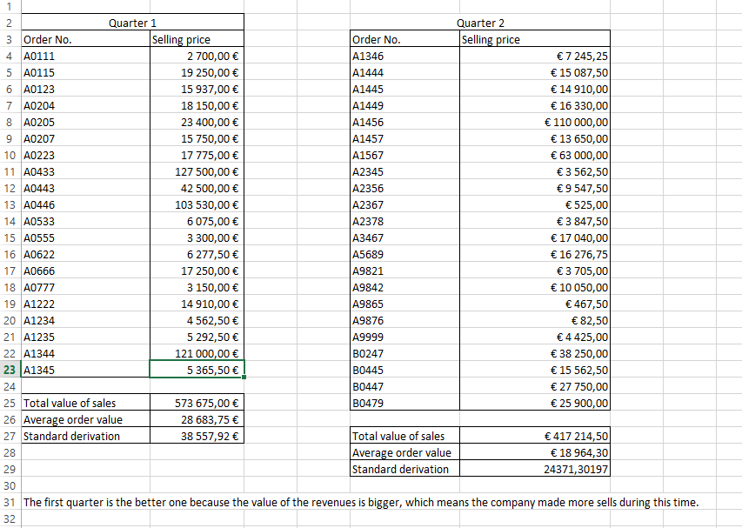

References

Alter, S., 2021. *How Effective Managers Use Information Systems*. [online] Harvard Business Review. Available at: <https://hbr.org/1976/11/how-effective-managers-use-information-systems> [Accessed 11 November 2021].

Blogger, G., 2021. *5 Ways To Use Technology In Your Business Growth Strategy*. [online] Yoh.com. Available at: <https://www.yoh.com/blog/5-ways-to-use-technology-in-your-business-growth-strategy> [Accessed 14 November 2021].

WSU Online MBA. 2021. *What Are Information Systems, and How Do They Benefit Business*. [online] Available at: <https://onlinemba.wsu.edu/blog/what-are-information-systems-and-how-do-they-benefit-business/> [Accessed 14 November 2021].